**Creating a Report**

**Note**: *This article applies to GPM v11.9.0 and later.*

Goliath Performance Monitor includes many report templates so you can begin to analyze and share data quickly. Beginning with version 11.9.0, all reports can be created from a single, streamlined report dialog that guides you through the process of selecting the report template, defining options and scheduling your report. The steps for creating a report using this dialog are described below.

**Creating a Report**

1. From the Report page, click mceclip1.png in the top right corner of the page to open the Report Dialog.
2. Select the report template to use and click **Next**. Based on the template selected you will have a few different options available in the step that follows.  
     
   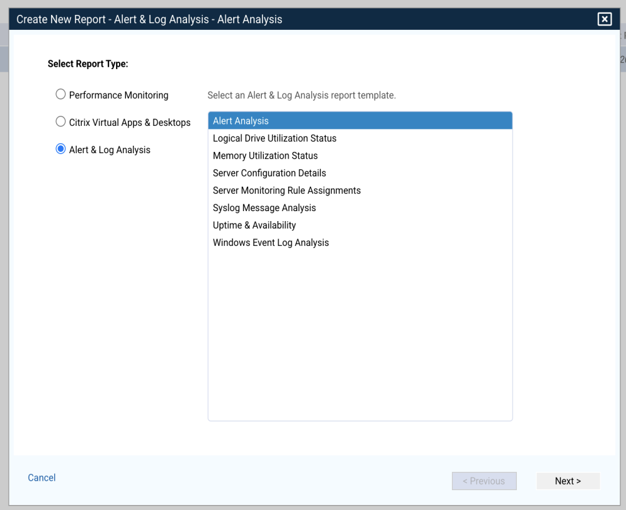  
     
   **Performance Monitoring Reports** let you select from a list of Windows performance counters, or click **Custom** to select your own counters to report on. Performance counters are collected by default every 5 minutes (Refer to the **Settings** page to change the collection period if needed). See below for a description of each [Performance Monitoring](https://support.goliathtechnologies.com/hc/en-us/articles/360050977373-Creating-a-Report#h_a87cb6ff-6477-4658-8c9a-b7b8fb372fe4) report template.  
     
   **Citrix Virtual Apps & Desktops Reports** will prompt you to select the default columns to display and a few report-specific display options based on the data collected. See below for a description of each [Citrix Virtual Apps & Desktops](https://support.goliathtechnologies.com/hc/en-us/articles/360050977373-Creating-a-Report#h_5dfab00f-0783-42e3-8d85-065fcdff2a66) report template.  
     
   **Alert & Log Analysis Reports** present specific options based on the report type related to the alert or log details in the report. See below for a description of each [Alert & Log Analysis](https://support.goliathtechnologies.com/hc/en-us/articles/360050977373-Creating-a-Report#h_63fa2d5a-d041-4c6e-8770-71619a6830bb) report template.
3. After selecting a template and the required report options, select the devices or groups to report on. Depending on the report type, devices or groups only may be available for selection.  
     
   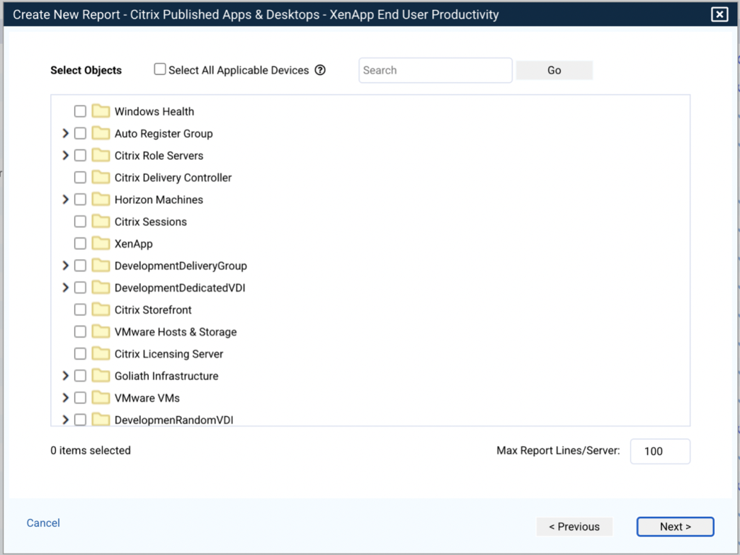  
     
   Check **Select All Applicable Devices**to automatically select only those devices that apply to the specific report template. For example, if you selected a Citrix XenApp report, only Citrix XenApp Servers will be included in the device selection each time the report runs  
     
   Depending on the report, typically Alert & Log Analysis reports, a lot of information may be included for each selected device. You can limit the amount of data to display for each device using the **Max Report/Lines Server** option.  
     
   After selecting the devices or groups to include, click **Next.**
4. Next, give the report a name and description and optionally assign a **Report Owner**. The report owner is displayed on the main report page to help you organize and view your available reports and also allows you to customize which reports individual users can see and access. Administrator GPM users can see and access all reports regardless of the Report Owner.  
     
   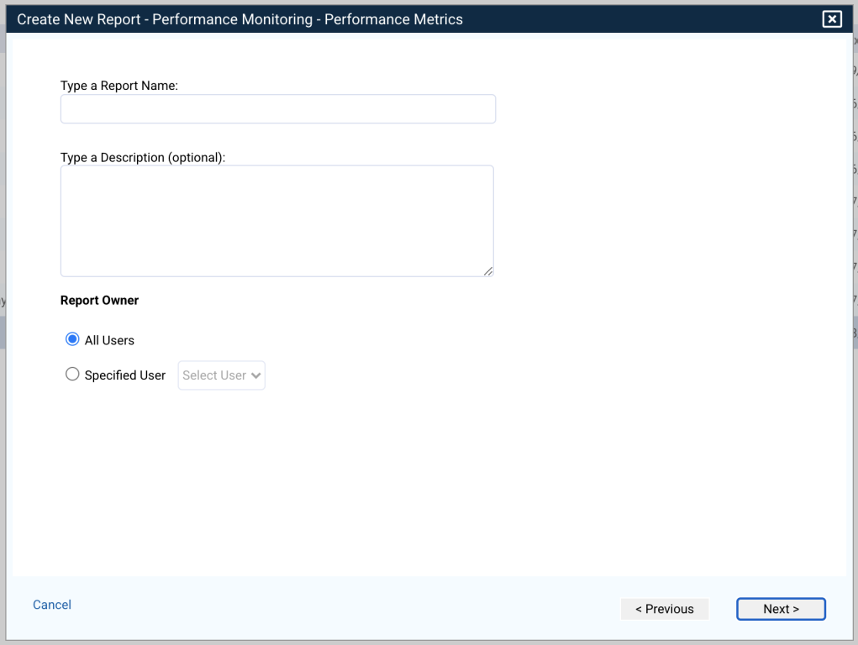  
     
   Click **Next.**
5. At the next step you will define your sharing options. Reports can be emailed or exported each time they are run. You can select to send the report as a PDF or CSV file. For reports to be emailed, SMTP settings must be configured. Max size of exported PDFs is 8MB. If a report would be over 8MB it will need to be exported as a CSV.  
     
   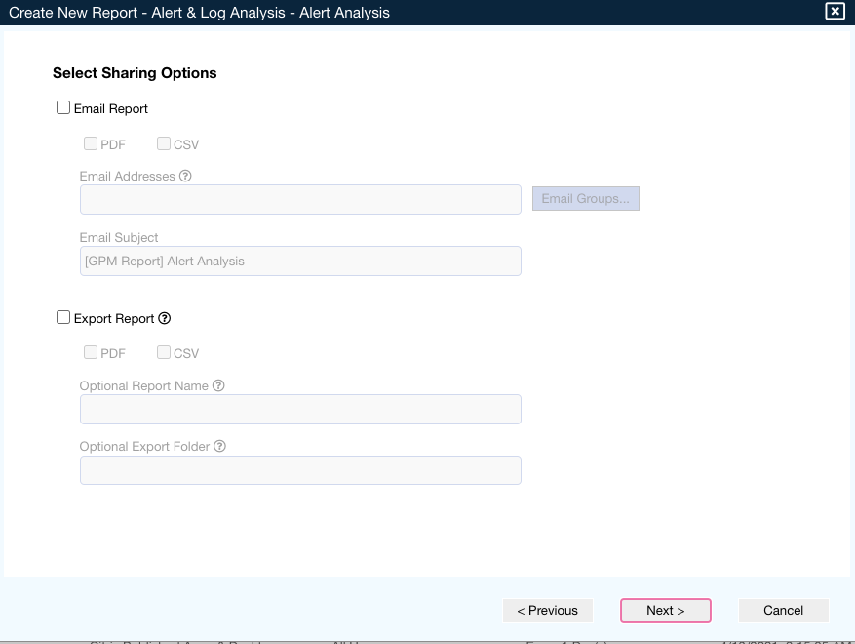  
     
   Click **Next.**
6. Finally, select how often to run the report and the timeframe to include each time the report runs.  
     
   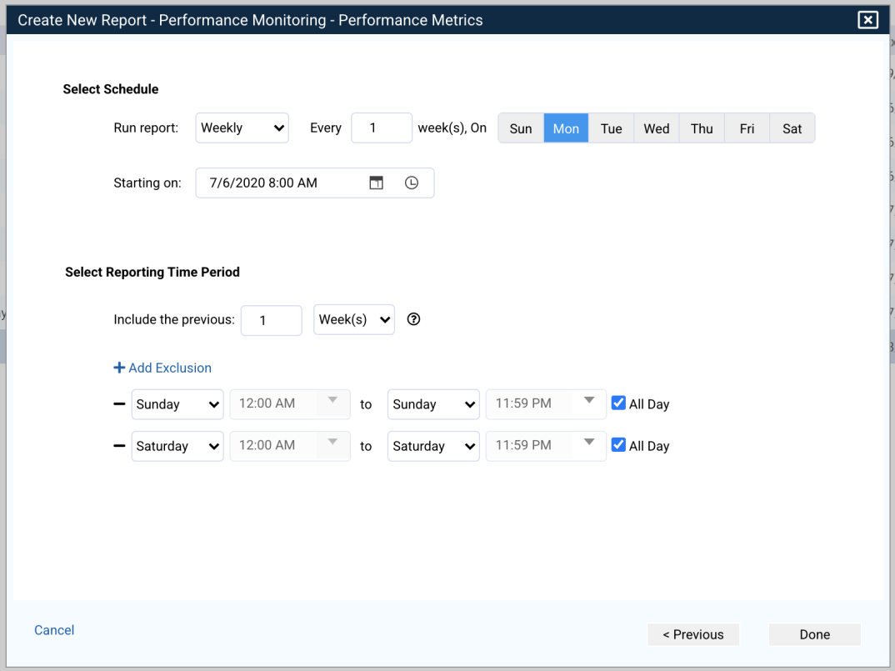  
     
   For example, to run a weekly report that includes the last week of data each time, you would select to run the report every Friday at 5pm and include the last 5 days. If you wanted to run the report on Sunday night, you could include the last 7 days and then exclude Saturday and Sunday using the options available.  
     
   You also have the option to create a report without a schedule by selecting **On** **Demand**. This lets you run the report anytime you need using the template and options selected.
7. Click **Done** to finish creating the report. The new report is displayed in the main report table.

**Note on creating reports and security permissions**

When creating a report, the "report creator" is the current user. The report is only able to retrieve data relating to objects to which the report creator has access.

When security is disabled within GPM, the current user is "System" (not a real user account and only valid if security is disabled).

If a user creates a report with security is disabled in GPM (meaning the report creator is "System"), then security is enabled later, they will need to recreate those reports. This can be done quickly using the individual report context menu **Copy** option.

**Report Template Descriptions**

The next few sections define the available report templates in detail.

**Performance Monitoring Reports**

The Performance Monitoring reports (Previously known as CounterWatch reports) allow you to report on Windows performance counter data. You can choose from templates that have been pre-configured to collect specific counters, or you can use the **Custom** option to build your own report and select your own specific Windows counters.

**Note**: Performance counters are collected by default every five minutes once the report is created. This can be changed by going to the **Report Settings** dialog of the **Settings** page.

The following templates are included out-of-the-box

|  |  |
| --- | --- |
| **Template** | **Description** |
| Internet Information Server (IIS) | Device-based report that displays IIS activity on the machine including active server pages and total web service activity. |
| Performance Metrics | Device-based report providing common performance metrics for all selected devices. Metrics include % disk time and free space, memory usage, processor %, file directory searches, logon, processor queue length, and active TCP connections. |
| TCP/IP | Displays IP and TCP counter details including fragment re-assembly and fragmentation failures for IP and connection and segment counters for TCP for selected devices. |
| Virtual Citrix XenServer - Host | Displays CPU %, available memory, total memory, network throughput transmit and received for selected XenServer host machines. |
| Virtual Citrix XenServer - Storage | Displays storage repository space available and total capacity for selected XenServer host machines. |
| Virtual Citrix XenServer - Virtual Machine | For selected XenServer virtual machines, displays CPU %, disk capacity, memory metrics, network throughput, and VBD throughput read and write. |
| Virtual VMware vSphere - Host | Displays CPU %, disk IOPS, latency, and throughput, memory counters including active, available, ballooned, consumed, granted, overhead, shared, swapIn, swapOut, total and network throughput for selected VMware hosts. |
| Virtual VMware vSphere - Storage | Displays datastore space available and total capacity for selected vSphere storage. |
| Virtual VMware vSphere - Virtual Machine | Displays CPU, Disk IOPS, Disk Throughput, Memory and Network counters for selected VMware virtual machines. |
| Windows Server/Desktop Analysis | Report includes many performance counters for selected devices including cache, logical disk, memory, paging file, processor and system. |
| Custom | The custom option lets you browse and select the performance counters you would like to include in the report. |

**Citrix Virtual Apps & Desktop Reports**

The following report templates are available for Citrix Virtual Apps & Desktops. For additional information refer to the [Citrix reports](https://support.goliathtechnologies.com/hc/en-us/articles/360034904954) knowledge base article.

|  |  |
| --- | --- |
| **Template** | **Description** |
| XenApp Client Report | Provides client details for specified time period, including Client Name, Address, Version, Directory, Device type and User name. In addition it displays Application information and date and time the record was recorded. |
| XenApp End User Activity | Displays total user count for specified time period, User Account Name, Display Name, Total sessions for the user, Active hours and Average hours per session and last session date and time. |
| XenApp End User Experience | An overview of user experience metrics per user including User Name, Application or Desktop launched in the session, Connect Time, Client Address, Citrix Fast/Slow metric, Logon duration, ICA Latency and Client Speed in ms. |
| XenApp Environment Summary | Graphical report that includes top 10% CPU and Memory used over time, ICA latency, Logon duration average and minimum, Total Session counts, and Total User counts over the time period specified. |
| XenApp ICA Latency | Displays ICA Latency per session including User details, client information, session name and ICA Latency, RTT and App names. Latency can be reported as average or maximum and you can display the top 20 users or only users with latency greater than a specified value. |
| XenApp License Usage | License details per Citrix group including minimum, average and maximum license usage in the specified time frame. Details are displayed in both table and graphical (bar chart) formats. |
| XenApp End User Productivity | Displays end user activity for the specified time frame. Activity includes mouse and keyboard interaction within the session. User, client, connection, and session details are included along with session duration, interaction time, inactivity max, and percentage of interaction as well as desktop/app details. |
| XenApp Peak Usage | Minimum, average, and maximum session usage details by group including interval max and overall max. |
| XenApp Server Health | XenApp server details including server load, disk free percentage, CPU used, memory, network latency, active users and uptime. |
| XenApp Session Activity | Session details by user including client information, last session state recorded, app name and connection and disconnection date and time. |
| XenApp Session Logon Duration | Logon duration details by session with user name, XA server, connection time and logon duration stage details as well as app or desktop name. |
| XenApp 4.5 - 6.5 End to End Connection | Session and client details for XenApp 4.5 to 6.5 including app name, connect time, user details, client information, broker, server, and user experience metrics, logon duration, latency and client speed. |
| XenApp 7.5 - 7.6 End to End Connection | Session and client details for XenApp 7.5 and 7.6 including app name, connect time, user details, client information, broker, server, and user experience metrics, logon duration, latency and client speed. |
| XenDesktop Client Report | Provides client details for specified time period, including Client Name, Address, Version, Directory, Device type and User name. In addition it displays VDI name and date and time the record was recorded. |
| XenDesktop End User Activity | Displays total user count for specified time period, User Account Name, Display Name, Total sessions for the user, Active hours and Average hours per session and last session date and time. |
| XenDesktop Environment Summary | Graphical report that includes top 10% CPU and Memory used over time, ICA latency, Logon duration average and minimum, Total Session counts, and Group Session counts over the time period specified. |
| XenDesktop Health Report | Displays VDI details including desktop group, machine name, IP, registration, summary, broker, hosting, user info logon and uptime. |
| XenDesktop ICA Latency | Displays ICA Latency per session including User details, client information, ICA Latency, RTT and desktop name. Latency can be reported as average or maximum and you can display the top 20 users or only users with latency greater than a specified value. |
| XenDesktop End User Productivity | Displays end user activity for the specified time frame. Activity includes mouse and keyboard interaction within the session. User, client, connection, VM name, and session details are included along with session duration, interaction time, inactivity max, and percentage of interaction. |
| XenDesktop License Usage | License details per Citrix group including minimum, average and maximum license usage in the specified time frame. Details are displayed in both table and graphical (bar chart) formats. |
| XenDesktop Peak Usage | Minimum, average, and maximum session usage details by group including interval max and overall max. |
| XenDesktop Session Activity | Session details by user including client information, machine name, summary state, host server, and login and state change date and time. |
| XenDesktop Session Logon Duration | Logon duration details by session with machine and user details, connection time and logon duration stage details as well as group name. |

**Alert & Log Analysis Reports**

The Alert & Log analysis report templates let you create reports to review alerts or logs over specified time periods as well as basic server configuration and availability information.

|  |  |
| --- | --- |
| **Template** | **Description** |
| Alert Analysis | Select specific monitoring rule alerts to report on over specified time frame. You can select from any of the available rule types within GPM (ServerWatch, EventLogWatch, WinServicesWatch, etc.) to review on demand or on a periodic basis (hourly, daily, weekly, monthly). EventLogWatch and SyslogWatch alert types also provide additional optional query parameters to further specify what you would like to report. |
| Logical Drive Utilization Status | Report on the drive status for devices within specified groups including drive letter, capacity, used, free and % free space as well as a graphical indicator to quickly see which drives are nearing capacity. |
| Memory Utilization Status | Report on the memory utilization for devices within specified groups including the total physical and available memory, total page size and available page size as well as % available. A graphical indicator also quickly displays which devices are running low on memory resources. |
| Server Configuration Details | Displays hardware configuration for devices within selected groups. Information includes, CDROM, System (type, manufacturer, model, processors), Disk drives (manufacturer, type, partitions, status, sectors), disk partitions, motherboard, network adapter, operating system, memory, printer, processor, system enclosure and video controller. |
| Server Monitoring Rule Assignments | Displays all monitor rules, by type, for each selected device including rule name, description, severity, details, schedule and action. |
| Syslog Message Analysis | Displays all received SYSLOG messages for selected devices including tag, date and time, facility, severity, and message details. Also includes optional query parameters to further refine the report. |
| Uptime & Availability | Displays uptime and availability for selected IP service type (PING, HTTP, FTP, SMTP, POP, DNS, USER, SQL, SNMP, TELNET, ORACLE, L_NOTES, ODBC, SIP, AGENT) on selected devices. Includes graphical report with frequency check, success ratio, availability, and performance. |
| Windows Event Log Analysis | Displays received Windows Event Log messages for selected devices including date and time, log name, type, source, ID, user name and message description. Also includes optional query parameters to further refine the report. |